**Topic 9: Big Data and Machine Learning in the Financial Industry**

* + 1. **Regulatory and supervisory issues around FinTech** FSB article

1. **Identify factors that may contribute to increases in 3rd party dependencies among financial institutions.**

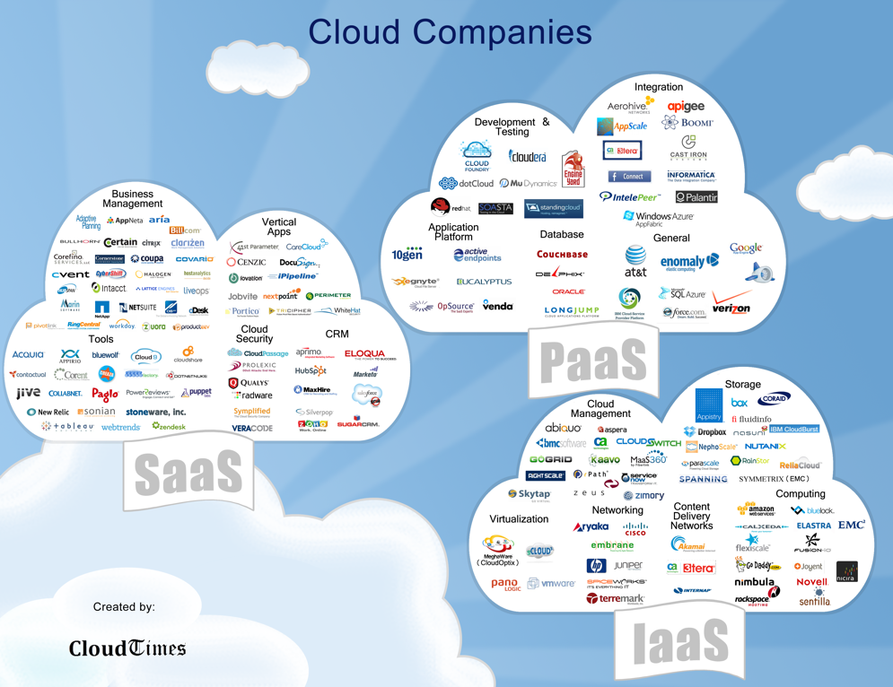

* There will be a reliance on third-party providers due to network effects and scalability of new technologies.

1. **Explain why unexpected forms of interconnectedness among institutions could be created.**

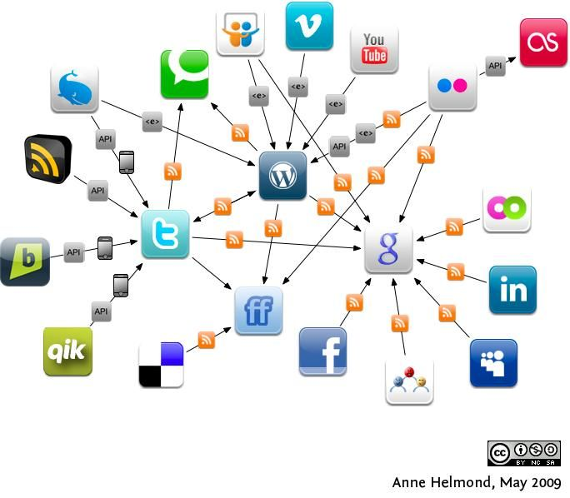

* There may be more interconnectedness based on various third-party data sources.
* The need for technical expertise to assess third-party providers’ controls may raise new risk questions.
* If a major provider of AI and machine learning tools were to become insolvent this could lead to many operational disruptions of financial institutions at the same time.

1. **Explain why new forms of MACRO-level risks could emerge.**



* The lack of INTERPRETABILITY or “auditability” of AI and machine learning methods could become a macro-level risk.
* Similarly, a widespread use of OPAQUE models may result in unintended consequences.

1. **Explain why new risk management tools and techniques may be required.**

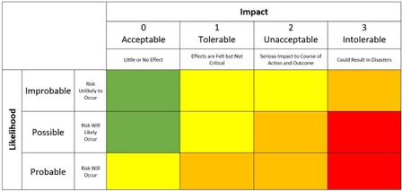

* Adherence to relevant protocols of data privacy, conduct risks, and cybersecurity.
* Adequate testing and ‘training’ of tools with unbiased data and feedback mechanisms important to ensure applications do what they are intended to do.

**9.1.2 Relationship between AI, machine learning, big data, and algorithms.** FSB article

1. **Describe the two recent developments that have contributed to increased interest in AI.**
2. Increases in computing POWER
3. Increase in the availability and quantity of DATA
4. **List factors contributing to making the markets more efficient**
5. AI and machine learning may enable collection of INFORMATION on a greater scale.
6. AI and machine learning may lower trading COSTS.
7. **Describe the relationship between AI, machine learning, and 3 algorithms of Figure 1.**

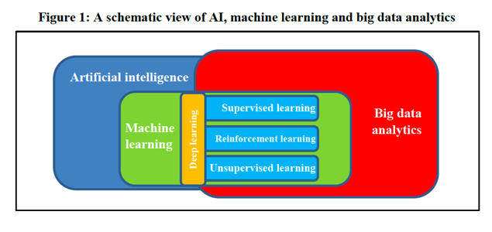

1. Supervised Learning
2. Unsupervised learning
3. Reinforcement learning.

* Two types of reinforcement learning are 1) Positive 2) Negative
* Two widely used learning model are 1) Markov Decision Process 2) Q learning
* Reinforcement Learning method works on interacting with the environment, whereas the supervised learning method works on given sample data or example. Think games for reinforcement learning.

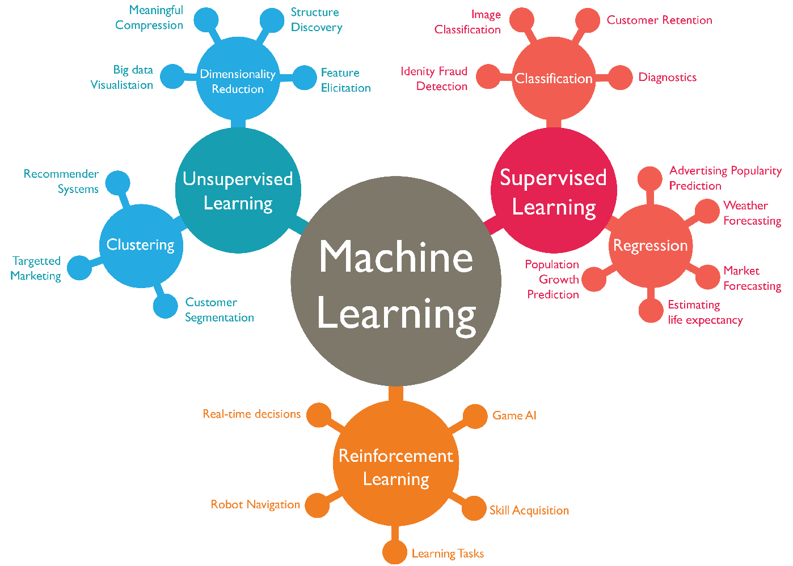

* + 1. **Categories of machine learning algorithms** FSB article

1. **Define 4 categories of machine learning algorithms based on the degree of human intervention.** Pg 5.
2. Supervised Learning
3. Unsupervised Learning
4. Reinforcement Learning.
5. Deep Learning

Reinforcement learning (RL) is an area of machine learning concerned with how software agents ought to take actions in an environment in order to maximize the notion of cumulative reward. Reinforcement learning is one of three basic machine learning paradigms, alongside supervised learning and unsupervised learning.

1. **Describe the role of ML algorithms in determining causality vs. correlation**

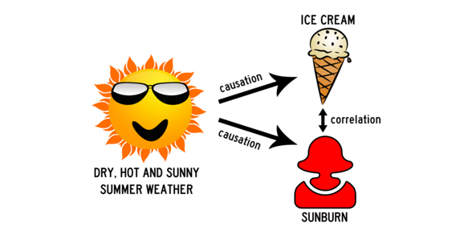

# A reminder that ML is about Correlations not Causation

ML is used to identify patterns that are correlated with other events or patterns.

1. **Define ‘augmented intelligence’**

Researchers and marketers hope the term *augmented* intelligence, which has a more neutral connotation, will help people understand that AI software will simply improve products and services, not replace the humans that use them.

1. **Explain the limitations of machine learning algorithms in determining causality and correlations.**



ML makes this discovery: Did you know that people with bigger hands have larger vocabularies? That is because they are correlated. The cause, however, is because of age. Adults know more words than younger people. Machines don’t recognize this.

A deep learning system might only be able to see the correlation but wouldn't be able to answer the 'why?' of it.

* + 1. **Drivers of growth in use of FinTech and adoption of artificial intelligence (AI).** FSB article

1. **Discuss the SUPPLY factors related to advances in computing technologies and changes in the financial sector**
2. Improved technology. Computing power.
3. Availability of infrastructure. Financial sector factors.

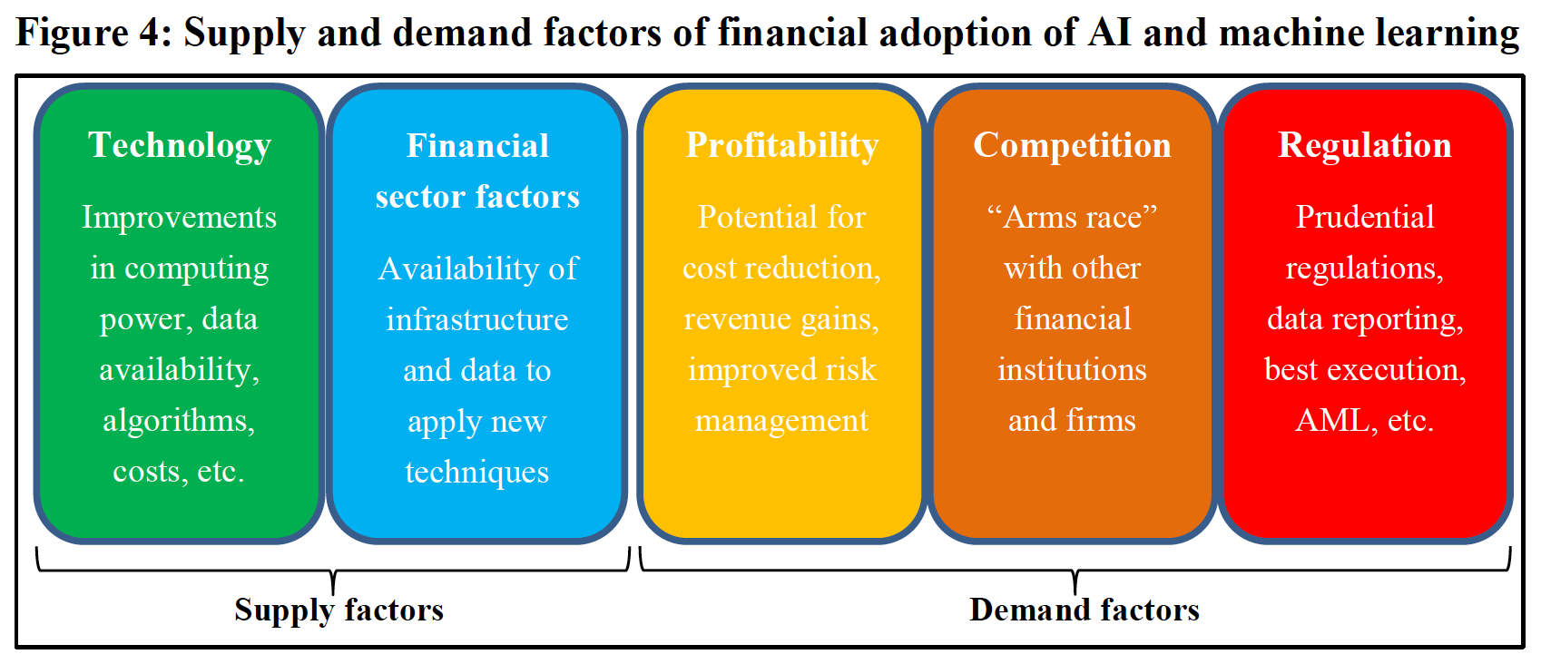

1. **Discuss the DEMAND factors related to search for higher profits, increased competition and changes in the regulatory environment.**
2. Profitability
3. Competition
4. Regulation / Reporting needs



* + 1. **USE CASES of artificial intelligence (AI) and machine learning (ML) in Financial Sector**. FSB article.

1. **Describe customer-focused uses such as credit scoring, insurance and client-facing chatbots.**
2. Credit Scoring

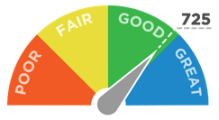

Banks and lenders have traditionally used regression trees, decision tress, and statistical analysis. Now they are starting to use social media like mobile phone use, text messages to improve the rating accuracy of loans. Always privacy issues.

With the absence of historical credit information AI and machine learning can find a way to score these individuals. There are firms going across seas like China to give loans to people with no history using AI and machine learning.

1. Insurance



IoT telemetric data are becoming a bigger deal. Sensors in toothbrushes, online shopping behavior, connected devices in the car. Dental health can be scored.

InsurTech is growing. AI can help reduce claim processing times.

1. Client-facing Chatbots



Virtual assistants that help customers transact or solve problems. NLP is a big deal or these applications. Asian institutions are leading the charge with ChatBot advancements.

1. **Describe operations-focused uses, such as optimal allocation of capital, risk management modeling, market impact analysis.** Pg. 15
   1. Capital ALLOCATION OPTIMIZATION by banks.

Margin Valuation Adjustments. MVA. Optimization of Risk Weighted assets. RWA.

AI will help with margin by executing offsetting derivatives trades, offsetting trades with the same dealer, novating trades from one dealer to another.

* 1. Model RISK management (backtesting and model validation).

Back testing is being conducted to evaluate how well the models of banks are performing. Stress tests are being conducted for banks with AI and machine learning.

* 1. Market IMPACT analysis (modelling of trading and big positions).

Trading robots are being created to learn how to trade out of positions. AI and machine used to assess the impact these trades will have on the market.

1. **Describe portfolio management and trading uses.**

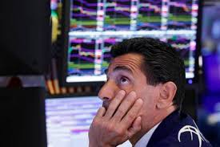

TRADING

1. Manage risk exposures.
2. Find more trade signals.
3. Better execution and timing of trades. Voice-to-text.
4. Compliance with regulation. RegTech.

PORTFOLIO MANAGEMENT

* 1. Identify new signals
  2. Generate higher and uncorrelated returns.
  3. Predictions of price levels and volatility at different time horizons.
  4. Get alt-data from news and 3rd party information
  5. Firms are reluctant to share statistics on ML because it is proprietary.

1. **Describe regulatory compliance and supervision uses by financial institutions, central banks macroprudential authorities, and market regulators.**



* + - * RegTech. NLP is the big factor for it all. Emails and text messages can be evaluated.
      * KYC. Know your customer. Match images of documents. Monitor police reports and other social media outlets. Look for red flags.
      * Data quality can be assessed. Identify data gaps, data inconsistencies, fat-finger errors and algorithms to identify data gaps.
      * Central banks can use AI and ML to assist with monetary policy assessments. ‘Nowcasts’ are going to become a big deal for GDP, unemployment, retail sales, tourism, business cycles with sentiment indicators.
      * Fraud detection. For example, the SEC is using AI and ML to identify patterns in text of SEC filings.
    1. **The MICRO-financial analysis of artificial intelligence and machine learning uses.** FSB article.

1. **Describe the uses of artificial intelligence (AI) and machine learning (ML) in information gathering and processing their potential impacts on financial markets.**
2. Greater scale of information gathering. AI and machine learning may enable certain market participants to collect and analyze information on a greater scale.
3. AI and ML will lower trading costs.

Note: Herding behavior could make shocks even bigger. Insiders and Cybercriminals could figure out how to manipulate the technologies and the markets.

1. **Describe the uses or artificial intelligence (AI) and machine learning (ML) in improving efficiency of financial institutions.**

For institutions…

1. Reduced costs. Automate routine processes and tailor products.
2. Better Risk Management.
3. Better collaboration between institutions and other industries like e-commerce.
4. **Describe the uses of artificial intelligence (AI) and machine learning (ML) by financial institutions and their potential impacts on customer and investors.**

For customers…

* 1. Lower fees
  2. Wider access to financial services and sources for funds.
  3. More ‘customized’ financial services

**9.1.7 The MACRO-financial analysis of uses of artificial intelligence (AI) and machine learning (ML) uses.** FSB article.

1. **Describe economic growth and enhanced economic efficiency that could result from the applications of AI and ML to financial services.**
2. More Efficient Risk Management of individual banks’ loan portfolio and insurers’ liabilities. AI and machine learning could help process information on the fundamental value of assets.
3. Better economies of scope with cooperation. Cooperation with e-commerce and financial services. The who buys ‘what, where, and when’ could foster better cooperation between e-commerce and the financial services. Improved ‘economies of scope.’
4. Better investments with AI and ML. More investments in more AI and machine learning will help growth. The growth in investments of AI and Machine learning can stimulate economic growth.
5. **Describe the implications of uses of AI and ML by financial institutions for market concentration and systematic importance of those institutions.**



1. THIRD PARTIES. Concentration of services could be increased in AI and ML third parties for functions of the financial system.
2. PROPRIETARY ACCESS. Financial firms may be able to leverage proprietary sources of big data to obtain substantial economies of scope.
3. AFFORDABILITY. Only large financial service companies may be able to afford development and innovation of technologies.
4. **Describe how the uses of AI and ML by financial institutions could be sources of greater stability and vulnerability in financial markets.**

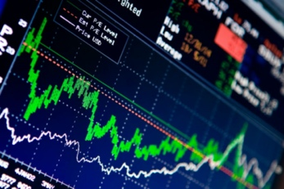

STABILITY

1. More investment customization
2. Reduced barriers of entry for access to more capital
3. New investment ideas for greater diversity in market movements
4. More efficient processing of information

VULNERABILITY

1. Advanced algorithms may act in unexpected ways to make risk harder to manage
2. High Frequency Trading (HFT) could be a new source of vulnerability

Harder to audit things.

1. **Describe how the uses of AI and ML by the insurance industry could affect both moral hazard and adverse selection problems.**



YOU WILL RUIN THE INSURAN CE POOL.

AI and ML could reduce Moral Hazard and Adverse Selection, but you might be undermining the risk pooling function of insurance.

Moral Hazard.

Smoking b/c you know you have life insurance

Adverse Selection

Not knowing that a person is a smoker.

1. **Describe challenges posed by the lack of interpretability or auditability in applications of AI and ML in the financial industry.**



* 1. Firms won’t understand the complexity of the AI trading strategies.
  2. The algorithms may be trained in low volatility periods not black swans
  3. Required skills may become more important for employees to have.
  4. Machine algorithms all doing the same thing creates overcrowding.

**9.8.1 The terms listed in the glossary:**

Describe the following terms: Algorithm, Artificial Intelligence, Augmented Intelligence, Big Data, Chatbots, Cluster Analysis, Deep Learning, Fintech, InsurTech, Internet of Things, Machine Learnings, Natural Language Processing, RegTech, Reinforcement Learning, Robo-advisors, social trading SupTech, Supervised Learning, Tonality Analysis, Topic modeling, and Unsupervised learning.

**9.2.1 Alternative Data and Institutional Investors**

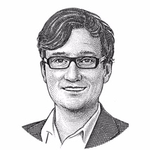Note: Ashby Monk

1. **Define alternative data and list examples of alternative data.**

Definition: Datasets which are not conventionally used for investment decision making.

1. **List the most commonly used types of alternative data**

 + Social CDE

1. Satellite Imagery
2. Social media streams
3. Consumer credit cards and other microdata (shopping)
4. Data scraped from the Internet (job postings)
5. Exhaust data which includes cookies, geolocation, searches
6. **Explain why the alternative data’s core value proposition is different for Institutional Investors.**

 

Institutional investors are better off designing their alt-data strategies around defense and defensible strategies rather than alpha-oriented opportunistic purposes.

1. **Discuss advantages and disadvantages that Institutional Investors may have in using alternative data.** 
   * 1. RIVALRY: losing the edge as more institutions get the data
     2. EXCLUDABILITY: preventing a competitor from getting the data.
2. **Discuss why the deepest value proposition alt-data has for Institutional Investors entails defensive and defensible strategies.**

 

Defensive strategies prioritize capital preservation and prudent risk taking over speedily exploiting opportunities. Alt-data can help to do this.

1. **List examples of how alternative data may be used defensively for understanding RISK**

 

1. Harvesting dynamic pricing information from online sources. Inflation metrics.
2. Aggregating labeled information. Nutrition, dietary trends.
3. Assembling online price and ratings histories. Yelp. AirBnB.
4. Using microsensors. Soil moisture. Internet of Things.
5. Controlling reputational risk by monitoring social media posts.
6. **Discuss the applications of alt-data to risk measurement and management for Institutional Investors.**

Alt-data can provide more context. When more variables are tracked, there is a higher likelihood of catching anomalous behavior that heralds atypical events.

* Asset oversight like real estate
* Due diligence in private markets with agency issues
* Orbital Insight images for project status
* Networks. Linked In. Venture Capital networks. Scraping news feeds. Understanding the strengths of a fund manager’s network.

1. **Describe the operational alpha gains by institutional investors through the use of alt-data sets.**



The chief idea behind operational alpha is to better align operational resources with investment strategies by elimination of internal inefficiencies.

It frees up room in the risk budget, and thus allows the pursuit of strategies with higher upside.

1. **Describe types of alternative data sets in terms of origins of the data set.**

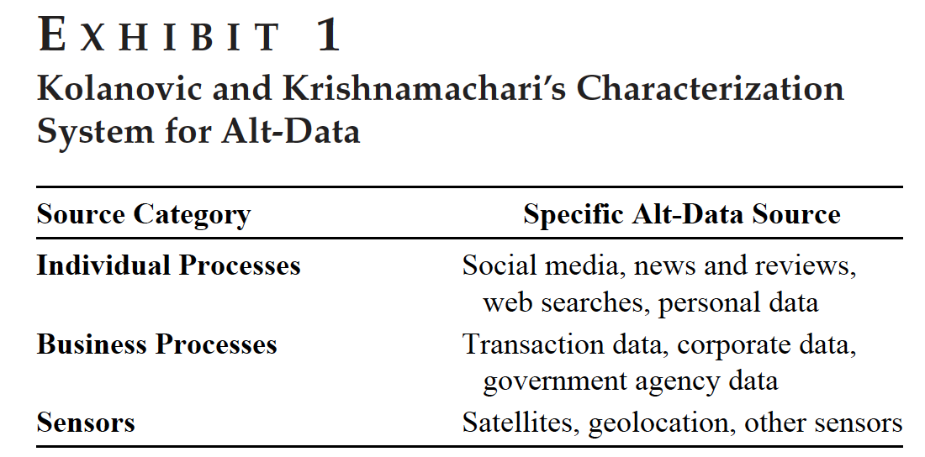 Note: IBS

1. **Discuss why the Volume, Veracity and Velocity of big data may not determine value of alternative data for institutional investors**



Note: Traditional is Volume, Variety, Velocity or Veracity.

Kitchin’s improvement:

Volume, Variety, Velocity, Comprehensiveness, Granularity, Relationality, Flexibility.

1. **Describe the 6-dimensional characterization of alt-data** p.21

FC RAGS

1. Freshness
2. Comprehensiveness
3. Reliability
4. Actionability
5. Granularity
6. Scarcity
7. **Discuss external asset managers and alternative data providers as of accessing alt-data.**



External asset manager = hedge fund

* Alpha is more important than capital preservation
* Lose ability to inspect the data
* Investor will be subsidizing the hedge funds

1. **Discuss the consequences of the increased use of alternative data on risk for institutional investors.**

 Note: Arms Race

Because the world is ever changing there is a continual production of new information. There can never be a fully efficient market. It is an ‘Arms Race’ for data.

1. **Compare accessing alternative through external asset managers and the alternative data vendors.**



Vendors

* Just provide the data and let the investors make decisions.
* Investors can examine data given to them
* Vendors are more trustworthy b/c they compete with each other
* Switching between data vendors is easier than switching asset managers
* You can customize the supplied data

1. **Describe rivalry and excludability (limited or permanent) as determinants of alternative data set’s value**

Rivalry has to do with the ‘edge’ it gives to the investor.

Excludability having proprietary .

**9.3.1 Applications of Random Forest (RF) regression algorithm to factor models.**



 Fama-French-Carhart

1. **Discuss 2 shortcomings of parametric nonlinear models that are developed to address shortcomings of linear models.** 
   * + - 1. Heavily dependent on SAMPLE data.

The structure of the parametric nonlinear model is often heavily dependent on the sample data. As the sample expands and contracts, the function specified by the model can change. Not good.

* + - * 1. Parameters cannot always be derived ANALYTICALLY. You have to use iteration.

Unlike linear models, parameter estimates cannot always be derived analytically. Rather, solutions are often found using iterative methods. But you may have an issue that the iterative values fail to converge.

1. **Discuss the ability of Random Forest (RF) algorithm to overcome one shortcoming of LINEAR models.**

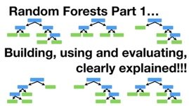

Why is the Random Forest better than Linear models?

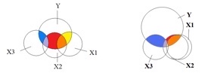Note: Multicollinearity visual

NO MULTICOLLINEARITY ISSUE

RFs are far less influenced by correlations between variables. Multicollinearity is not a problem. It does not require inversion of covariance matrix.

NO STRICT PARAMETIC ASSUMPTIONS

RFs do not have strict parametric assumptions. They do not rely on time series assumptions like homoscedasticity or the independence of errors.

**Advantages of Random Forests:**

* Performance is competitive with the best supervised learning methods
* Provides a more reliable estimate of feature importance
* Allows you to estimate out-of-sample error without using train/test split or cross-validation.

**Disadvantages of Random Forests:**

* Less interpretable
* Slower to train
* Slower to predict

1. **~~Discuss the ability of random forest (RF) algorithm to overcome one shortcoming of PARAMETRIC NONLINEAR models.~~**

DUPE

1. **List 4 components of the decision tree when applied to the regression problem of factor models.**

1. Root node

2.Internal nodes

3. Edges

4. Leaf nodes

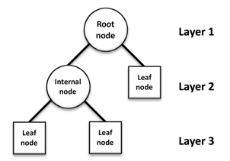

A decision tree is a decision support tool that uses a tree-like model of decisions and their possible consequences, including chance event outcomes, resource costs, and utility. It is one way to display an algorithm that only contains conditional control statements.

1. **Describe how bagging is used in an ensemble of decision trees (RF).**

Bootstrap aggregation = bagging. Portmanteau.

Bagging is useful because it generally reduces overfitting and has a lower variance when compared to processes that only use individual decision trees.

1. **Calculate the predicted value of a dependent (response) variable given a set of predictor values and the outputs of a binary regression decision tree algorithm.**

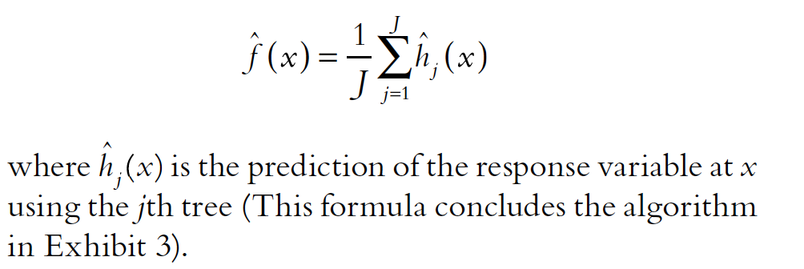



1. **Describe the role of out-of-the-bag observations in a random forest (RF) algorithm.**

After you bootstrap for RF algorithm. The set left out is Out-of-Bag.

It is used for testing.

1. **Discuss Mean Decrease Accuracy (MDA) approach to estimating feature importance in a random forest (RF) algorithm.**

 Note: Model is diluted

MDA measures the degree to which the predictive power of the model would be diluted if the values for the explanatory variable were changed.

1. **Recognize and apply the Probabilistic Sharpe ratio (PSR)**

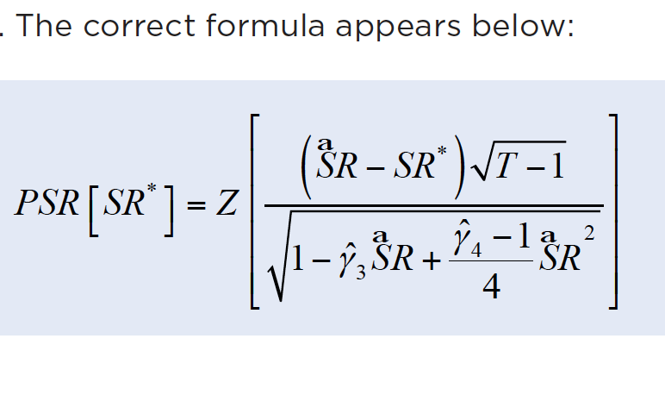

The estimated Sharpe Ratio always follows a Normal Distribution even if the returns do not.

The estimation errors on the SR increases with negatively skewed returns and fatter tails (big kurtosis). In those cases, it will be needed a longer track-record for decreasing these errors.

The Probabilistic Sharpe Ratio is a powerful statistic that gives us the confidence level associated with a particular SR estimation.

Hedge Fund 1 looks better.

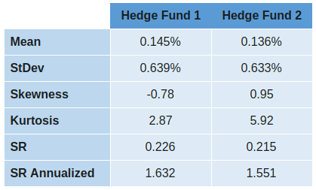

With the PSR Hedge Fund 2 looks better.

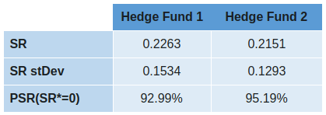

Deflated Sharpe Ratio

Essentially, DSR is a PSR where the rejection threshold is adjusted to reflect the multiplicity of trials.

**9.4.1 The applications of machine learning algorithms to STOCK selection.**

 Note: Rasekhschaffe. Two ways to reduce overfitting.

* 1. Feature engineering. Frame the problem and transform data for better signals.
  2. Forecast combinations. Use different MLA’s and training windows.

1. **Describe the role of signal-to-noise ratio in creating overfitted models**

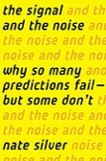

HIGH is good for Signals Vs. Noise (a lot from overfitting)

LOW Signal-to-Noise ratios in security selection means that overfitting is always a risk, especially with techniques like Machine Learning Algorithms (MLAs) that provide little structure to the analysis.

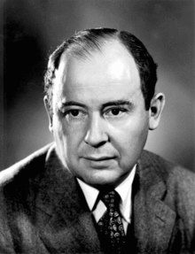 John von Neumann once said, “with four parameters I can fit an elephant, and with five I can make him wiggle his trunk.”

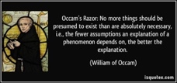

Note: Occam’s razor

“More things should not be used than are necessary.”



Note: Dr. Woodward.

"When you hear hoofbeats behind you, don't expect to see a zebra.”



Note: Ronald Coase

﻿ “If you torture the data long enough, it will confess.”

1. **Discuss the implications of the paper’s findings with regard to IN-SAMPLE VS. OUT-OF-SAMPLE errors as the number of boosting iterations increase**

Over-fitting will give you an enormous error on an out-of-sample dataset.

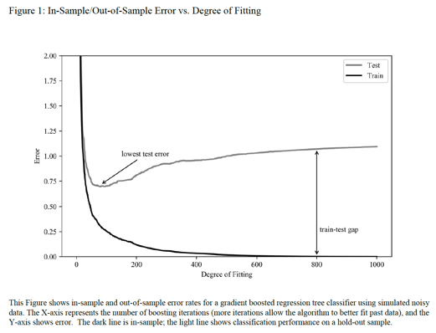

1. **Describe the 4 different approaches to bagging and boosting employed by the paper to avoid OVERFITTING.**

Four different approaches to avoid overfitting:



Note: Look out Class Window from Library to Horizon

1. Classes of algorithms. Bagging.
2. Training windows. Seasonality.
3. Factor libraries. Subsets of data.
4. Time horizons. Fundamental for longer and technical for shorter.
5. **Explain the importance of feature engineering and the role of subject matter expertise (SME) in mitigating the overfitting problem.**

Feature engineering is where domain knowledge flows into the process.

A feature is an attribute or property shared by all of the independent units on which analysis or prediction is to be done. Any attribute could be a feature, as long as it is useful to the model.

It is one of the most effective ways of overcoming overfitting because it allows us to increase the signal-to-noise ratio before training the algorithms.

1. **Describe the 3 decisions which must be made with regard to the forecasting goals of the machine learning algorithms.**
2. What are we Forecasting?
3. Which categories? Which discreet variables should we use to limit overfitting? Rather than just trying to forecast returns you can do categories like underperformer vs performer which tend to be less noisy.
4. How do you define these categories? Which sector or industry. How do you define these categories to improve signal to noise? Selecting categories on a risk-adjusted return basis to reduce noise. Fama-French or MSCI-Barra model.
5. Which time horizon? What is your forecast horizon? Short time horizons are for low capacity and high turnover. Short time horizons also mean more training periods.

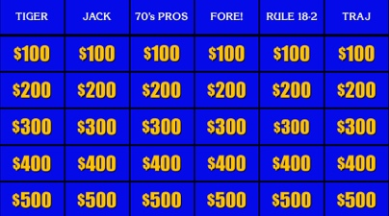 Note: Categories

1. **Describe the bias VS. variance tradeoff.**

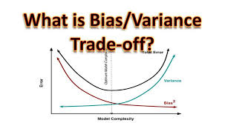

1. **Explain the role of bagging (bootstrap aggregation) and boosting in affecting the bias versus variance trade off.**

**Bagging** is a way to DECREASAE THE VARIANCE in the prediction by generating additional data for training from dataset using combinations with repetitions to produce multi-sets of the original data. Bagging = Bootstrap aggregation. It generally lowers overfitting and has a lower variance. LOWERS OVERFITTING.

Averaging trees ends up uncovering more general patterns and relationships amongst the variables. An individual tree can be highly idiosyncratic.

**Boosting** is an iterative technique which adjusts the weight of an observation based on the last classification.

Adjusts the weights. By giving weight to the more successful learners, boosting can address bias. However, if you give weight to too many weak learners you will increase the variance.

Boosting algorithms take longer to train because they are run sequentially.

1. **Understand the terms appearing in the glossary:** activation function, artificial neural networks and deep learning, bagging, boosting, dropout, gradient boosted trees, random forest.

**9.5.1 Applications of machine learning algorithms to Empirical Asset Pricing.**



Gu, Kelly, Xiu. Chicago Booth authors. Gu & Xiu. They forecast stock returns with a large set

of the firm’s characteristics and macro-variables.

**Describe the 3 components of the definition of machine learning.**

 Note: DARia

1. A diverse collection of high Dimensional models for statistical prediction with,
2. Regularization methods for model selection and mitigation of overfit with
3. Efficient Algorithms for searching among a vast number of potential model specifications.

**Describe the 3 aspects of empirical asset pricing model that makes it attractive for the applications of machine learning applications.**

PC Am

1. ML is specialized for prediction which is good for predicting risk premium measurement.
2. ML is good at condensing redundant variation among predictors.
3. ML is well suited for problems of ambiguous functional form

**Compare and contrast the overall performance of linear VS. nonlinear models in predicting individual stock returns and portfolio returns.**

Machine learning can outperform with non-linear models.

**Explain one potential shortcoming of machine learning algorithms when used to predict asset returns.**

Machine learning algorithms excel at uncovering subtle, contextual, and non-linear relationships; “overfitting” can be a problem. A model picking up noise instead of signal is known as overfitting.

**Describe the roles of “training set”, “validation” set, and “testing” set in using machine learning algorithms to predict stock returns.**

**Training Dataset:** The sample of data used to fit the model.

**Validation Dataset:** The sample of data used to provide an unbiased evaluation of a model fit on the training dataset while tuning model hyperparameters. The evaluation becomes more biased as skill on the validation dataset is incorporated into the model configuration.

**Test Dataset:** The sample of data used to provide an unbiased evaluation of a final model fit on the training dataset.

If our model does much better on the training set than on the test set, then we’re likely overfitting.

For example, it would be a big red flag if our model saw 99% accuracy on the training set but only 55% accuracy on the test set.

**Recognize the Huber loss function**

Less sensitive to outliers. Note: Mayor Assistant. Become less sensitive to outliers.

In statistics, the Huber loss is a loss function used in robust regression, that is less sensitive to outliers in data than the squared error loss.

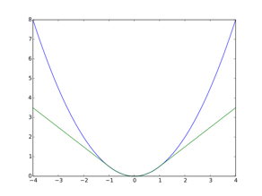

**Describe the benefit of using the Huber loss function as opposed to ordinary least squares (OLS) method to the estimation of linear models.**

Huber vs. OLS.

Huber is LESS SENSITVE TO OUTLIERS.

Huber loss is less sensitive to outliers in data than the squared error loss. It's also differentiable at 0.

**Recognize the “elastic net” approach for modeling penalized linear models.**

The simple linear model is bound to fail in the presence of many predictors. It begins to overfit noise instead of extracting signals. You need to penalize to reduce the number of predictors. Use Elastic Net. Rho is for Ridge and theta is for Lasso.

Elastic Net = LASSO + Ridge Regression.

Elastic net regularization. The elastic net is a regularized regression method that linearly combines the L1 and L2 penalties of the lasso and ridge methods.

**Compare and contrast “elastic net” penalty VS. LASSO and Ridge Regression.**

Elastic Net combines the LASSO and Ridge Regression penalties.

For modeling linear models:

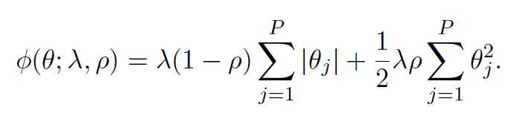

**Compare and contrast the Principal Components Regression (PCR) VS. Partial Least Squares (PLS).**

PRINCIPLE COMPONENTS REGRESSION (PCR)

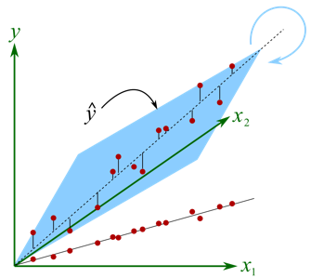

PCR tries to explain the variance-covariance structure of a data set. Aim is to increase the variance of the features itself, like the loss of information is greatly reduced.

When you reduce features using PCA, the idea is to maximize the variance of the features itself, such as the loss of information is greatly reduced.

However, the PCA only looks at those features as high-dimensional points and do not take into account the classification label associated to them.

A drawback of PCR is that it fails to incorporate the ultimate statistical objective – forecasting returns – in the dimension reduction step.

PARTIAL LEAST SQUARES (PLS)

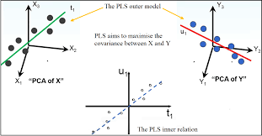

PLS

Partial Least Squares regression (PLS) is a statistical method that bears some relation to Principal Components Analysis (PCA); instead of finding hyperplanes of maximum variance between the response and independent variables, it finds a linear regression model by projecting the predicted variables and the observable variables to a NEW SPACE.

A drawback of Principal Component Regression (PCR) is that it fails to incorporate the ultimate statistical objective – forecasting returns – in the dimension reduction step. PCA condenses data into components based on the covariance AMONG the predictors.

In contrast, Partial Least Squares performs dimension reduction by directly exploiting covariation of predictors with the forecast target.

For each predictor X you estimate its univariate return prediction coefficient using OLS. This coefficient reflects the “partial” sensitivity of returns to each predictor.

**Recognize and describe the 3 sources of forecast error (decomposition of forecast errors).**

****Note: AEI weather forecast.

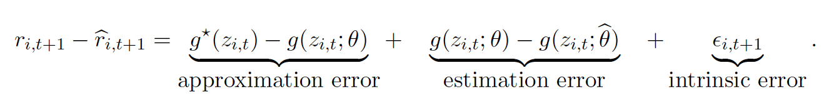

AEI

1. Approximation Error

2. Estimation Error

3. Intrinsic Error

**Describe the boosting regularization method in context of regression trees.**

Gradient boosting is a machine learning technique for regression and classification problems, which produces a prediction model in the form of an ensemble of weak prediction models, typically decision trees.

It builds the model in a stage-wise fashion like other boosting methods do, and it generalizes them by allowing optimization of an arbitrary differentiable loss function.

Tree stump example is ADA Boost.

**Describe the Random Forest (RF) regularization method in the context of regression trees.**

One straight-forward way is to limit the maximum allowable tree depth. The common way for RF classifiers to overfit is when they get too deep.

Thus, you can use the maximum depth parameter as the regularization parameter - making it smaller will reduce the overfitting and introduce bias, increasing it will do the opposite.

**Describe the dropout method in the context of Random Forest (RF) regression trees.**

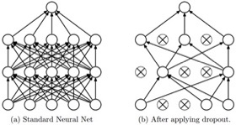 Example of a dropout variable to slim down model.

Dropout is a regularization method that approximates training a large number of neural networks with different architectures in parallel.

Dropout = A Simple Way to Prevent Neural Networks from Overfitting

**Recognize the Rectified Linear Unit (ReLU) activation function in the context of neural networks.**

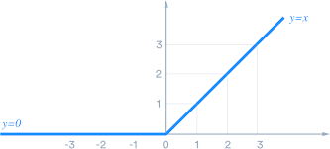 Negative inputs will OUTPUT zero. 

In artificial neural networks, the activation function of a node defines the output of that node given an input or set of inputs.

Very popular for deep learning networks. Easy to train and performs better.

ReLu is being used instead of sigmoid.

**9.6.1 The most common ERRORS made when machine learning techniques are applied to financial data sets.**  Marcos Lopez de Prado.

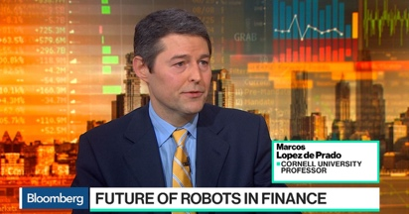

Ten Most Common ERRORS when ML is applied to financial data sets:

* + 1. The Sisyphus paradigm for Investment teams (all doing the same thing). Fail.

Solution- The meta-strategy paradigm: Organized collaboration of an investment team like an assembly line of specific skills. You also want siloed team isolation otherwise strategies become overcrowded. Team should have specific tasks for collaboration.



* + 1. Research through Backtesting. Fail.

Solution- Feature importance analysis: Hunters do not eat everything the dog brings back. Repeating a test over and over will lead to a false discovery. Feature importance is a research tool and backtesting is not. You want feature engineering.

 Note: “Hunters don’t eat everything the dog brings back”

* + 1. Chronological Sampling. Fail.

Solution- The Volume clock: Use dollar bars, trade bars, volume bars instead of time bars. Open close have a volume spike which time doesn’t capture.



* + 1. Integer Differentiation. Fail.

Solution- Fractional Differentiation: You want stationarity with some memory. Prices have some memory, and you want to retain some of this memory. You want to be between stationarity at minimal cost of eradicating memory.



* + 1. Fixed-Time Horizon LABELING. Fail.

Solution- The Triple-Barrier method: Label conditions that cause and exit of investment strategy.

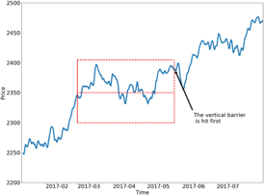

* + 1. Learning Size and Side simultaneously. Fail.

Solution- META-labeling: Split the size and side into two models. You want to increase the F1 score. Side is a buy or a sell while the Size is more risk management. You want to SPLIT these two decisions into two models. If you have high precision and low recall in trading, then you are being too conservative. Use the F1 score.

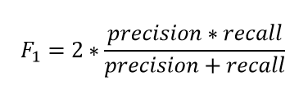

* + 1. Weighting of non-independent identically distributed samples. Fail.

Solution- Uniqueness weighting and sequential bootstrapping. Sequential bootstrapping can significantly increase the average uniqueness of samples.   
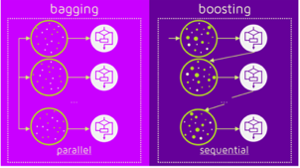 Note: Boosting is sequential

* + 1. Cross-validation Leakage. Fail.

Solution- Purging and Embargoing: Remove any training data that has cross overs with the testing data.



* + 1. Walk Forward Testing or Historical Back Testing. Fail.

Solution- Combinatorial Purged Backtesting: Generate thousands of train/test splits so that every part of the series is tested multiple times.



* + 1. Backtest Overfitting. Fail.

Solution- The Deflated Sharpe Ratio. Prado’s favorite.

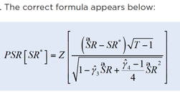

1. **Compare and contrast the SILO approach in discretionary strategies vs. Meta-strategy in ML strategies.**



Every portfolio manager should be put into a Silo (isolated). Otherwise, you would be paying 50 people and not getting the diversification of 50 different PMs. You want them to interact as little as possible.

BUTthis doesn’t work for Quants (Machine Learning).

1. A false positive on overfit back tests
2. Standard factor investing, which may be an overcrowded strategy with a low Sharpe ratio but at least has academic support.

The roles need to be broken down into subtasks.

1. **Compare and contrast repeated back testing using machine learning VS. examining feature importance of results from a machine learning application.**

 Note: “Hunters don’t eat everything the dog brings back”

Back testing: using PAST data to test a trading system. It refers to applying a trading system to historical data to verify how a system would have performed during the specified time period.

Even if we use the WF out-of-sample approach, the algorithm has been trained on in sample data over and over.

This practice is so bad that the ASA thinks of it as fraud. Eventually, you will run into a false positive. It typically takes about 20 iterations before you run into a false positive.

α = 5%. This is your false positive rate. Which is 1/20.

VS.

Feature Importance. Hunters don’t eat everything that their hunting dogs bring back to them. Which features are important? Are the features correlated to each other at all?

1. **Describe the 2 PROBLEMS with data sample generated with TIME BARS**.

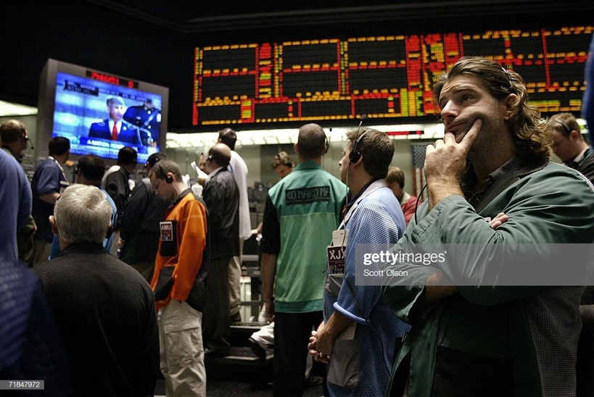

Note: Your busiest time in the 5yr pit was the open and close

Two Problems with Time Bars:

1. Markets do not receive inform ation at a CONSTANT time interval. It’s much busier at the opening and at the close. Note: Your 5-year pit trading during open/close.
2. Time samples tend to exhibit POOR STATISTICAL PROPERTIES (e.g., serial correlation, heteroskedasticity, and non-normality or returns. Incidentally, GARCH was created to help with this problem.
3. **Describe the advantages of Dollar Bars VS. Time Bars in creating data for machine learning algorithms.**

Better to use Dollar Bars instead of Time Bars.



1. Dollar bars better to show amount exchanged.
2. Better measure for shares exchanged.
3. **Describe the benefit of using fractional differentiation (FracDiff) in generating stationary series and preserving memory.**

 Note: No roots = stationarity

FracDiff vs Integral Differentiation

STATIONARITY and PRESERVING MEMORY

You want stationarity for pricing buy you also want to maintain some kind of memory.

Fractional differencing allows us to achieve stationarity while maintaining the maximum amount of memory compared to integer differencing.

1. **Explain the triple-barrier method for LABELING observed returns.**

In the majority of the literature, authors will make use of a labeling scheme where they classify the next periods directional move as either a 1 for a positive move, a -1 for a negative move, and some authors may add a threshold level that if the return is not above or below it, then a 0 label is provided.

This technique has flaws:

First the threshold level is usually static and stock returns are known to be heteroskedastic, the volatility changes over time and a fixed threshold value fails to account for this.

Second, using this {-1, 0, 1} scheme fails to account for positions that would have been closed by STOP loss or profit taking orders.

It is better to make use of a labeling scheme where they classify the next periods directional move as either a 1 for a positive move, a -1 for a negative move, and some authors may add a threshold level that if the return is not above or below it, then a 0 label is provided.

Should the path of a stock reach the upper barrier before the vertical then a value of 1 is returned, conversely if it reaches the bottom barrier then a -1, however should the stock price reach the vertical barrier first then a 0 is returned. This is still a {-1. 0, 1} scheme, however we are labeling a PATH of returns rather than the next directional move.

The 'Triple-Barrier' refers to the strategy's two horizontal and one vertical 'barriers' (price or time-based sell signals). See chart.

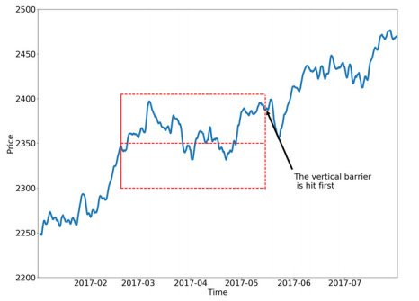

1. **Describe the definitions of precision, recall and F1-score as features of machine learning algorithms.**

Build something that has high RECALL (e.g., predict rallies) even if precision is not that high. You’ll miss big opportunities if you are too conservative.

Split the size and side into two models. You want to increase the F1 score. Side is a buy or a sell while the Size is more risk management. You want to split these two decisions into two models. If you have high precision and low recall in trading, then you are being too conservative. Use the F1 score.



We correct for low precision by labelling our bets. META-LABELING.

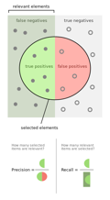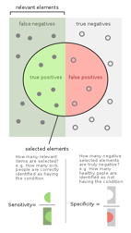

1. **Explain the role of non-independent identically distributed in returns in the failure of k-fold cross validation in finance.**



K-fold cross validation has problems when it leaks. Cross validation LEAKAGE occurs when information makes it into the testing data set.

Purge your data of all overlaps in time with the training and the testing data. Do an embargo of data when you have a time relation between test and training data.

1. **Describe the walk forward (WF) approach to back testing of trading strategies.**



Walk forward optimization is a method used in finance to determine the optimal parameters for a trading strategy.

Walk-forward optimization carries the idea of 'out-of-sample' testing to the next level. It is a specific application of cross-validation which rolls time period forward.

1. **Describe advantages and disadvantages of the walk forward approach.**

 Note: Pardo strategy

Advantages:

1) It has a very CLEAR historical interpretation

2) It is easy to find data which is out-of-sample. No LEAKAGE to the testing set.

Disadvantages:

1. A single path is tested which can be easily OVERFIT.
2. Results can be BIASED by the particular set of data points.
3. **Explain the relationship between the maximum Sharpe ratio obtained from several back tested strategies and the return volatility of those strategies**

 Note: Number of Trials

Maximum Sharpe ratio VS. Return Volatility of those strategies.

WF backtests exhibit high variance for a least one reason: A large portion of the decisions are based on a small portion of the dataset.

Researchers will select the backtest with the maximum Sharpe ratio, even if the true Sharpe ratio is zero. That is why it is imperative to control for the number of trials in the context of WF back testing.

The deflated Sharpe ratio will account for the number of trials for a probabilistic Sharpe ratio.

1. **Describe the concept of Probabilistic Sharpe Ratio (PSR).**



The probabilistic Sharpe ratio (PSR) provides an ADJUSTED estimate of the Sharpe Ratio by REMOVING the inflationary affect caused by short series with skewed and/or fat-tailed returns.

The Probabilistic Sharpe Ratio (PSR), developed in Bailey and López de Prado, computes the PROBABILITY that the true SR is above a given threshold. This rejection threshold is determined by the user.

PSR takes into account the sample length and the first four moments of the returns’ distribution.

* 1. The mean, which indicates the central tendency of a distribution.
  2. The second moment is the variance, which indicates the width or deviation.
  3. The third moment is the skewness, which indicates any asymmetric ‘leaning’ to either left or right.
  4. The fourth moment is the Kurtosis, which indicates the degree of central ‘peakedness’ or, equivalently, the ‘fatness’ of the outer tails.

Essentially, DSR is a PSR where the rejection threshold is adjusted to reflect the multiplicity of trials.

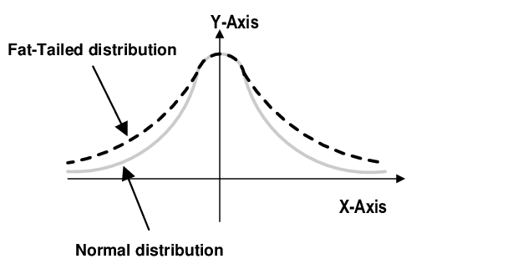

1. **List the impacts of nonnormalized Sharpe ratio, length of track record, skewness & kurtosis on Probabilistic Sharpe Ratio (PSR).**



Time Frame. Thousands of hedge funds have not even been through a complete business cycle. For those that have, many have experienced a change of managers or a change in strategies. You need full time frame.

Skewness & Kurtosis. For instance, a simple strategy of selling deep out-of-the-money options tends to collect small premiums and pay out nothing until the "big one" hits. Until a big loss takes place, this strategy would show a very high Sharpe ratio.

Serial correlation. Autocorrelation can also overstate a Sharpe ratio when present in month-to-month returns. According to Andrew Lo in "The Statistics of Sharpe Ratios" (2002), this effect can cause the ratio to be overstated by up to 65%. This is because serial correlation tends to have a smoothing effect on the ratio.

Long-Term Capital Management (LTCM) had a very high Sharpe ratio of 4.35 before it imploded in 1998.

Just as in nature, the investment world is not immune to long-term disaster, for example, like a 100-year flood. If it weren't for these kinds of events, no one would invest in anything but equities.

The problem with the Sharpe ratio is that it is accentuated by investments that don't have a [normal distribution](https://www.investopedia.com/terms/n/normaldistribution.asp) of returns.

The best example of this is hedge funds. Many of them use dynamic trading strategies and options that give way to [skewness](https://www.investopedia.com/terms/s/skewness.asp) and [kurtosis](https://www.investopedia.com/terms/k/kurtosis.asp) in their distribution of returns.

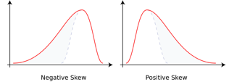

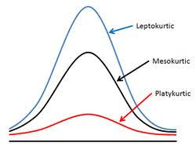

Note: Types of Kurtosis:

“Leptokurtic” is very skinny like a leper.

“Mesokurtic” is in the middle.

“Platykurtic” is flat like a plateau.

**9.7.1 Using statistical techniques to evaluate trading strategies in the presence of MULTIPLE TESTS.** Harvey and Liu. Evaluating trading strategies. IPR.

1. **Describe why standard statistical tools, such as p-values and t-statistics can lead to false discoveries (FDR) in the presence of multiple tests.**

The more hypotheses we check, the higher the probability of a Type I error (false positive).

When people say “adjusting p-values for the number of hypothesis tests performed” what they mean is controlling the Type 1 control rate.

The bigger the sample, the more ‘false positives.’

1. **Calculate the t-statistic based on reported Sharpe ratio for testing a SINGLE trading strategy.**

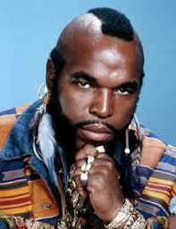 **=**  sharpest. x √ oldest

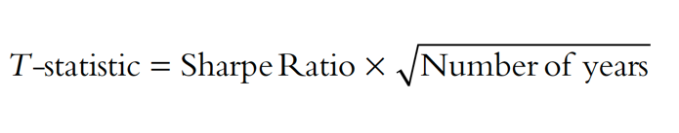

1. **Describe and apply Bonferroni tests in the context of the family-wise error rate (FWER) approach to adjusting p-values for multiple tests.**

 

Note: Make your data less significant by lowering the p-value.

FWER: Family Wise Error Rate



FWER has at least one False Positive.

Stricter than the FDR. It takes just one false positive.

The Bonferroni test attempts to prevent data from incorrectly appearing to be [statistically significant](https://www.investopedia.com/terms/s/statistically_significant.asp) by lowering the p-value.

Made for inflated Type I error (the higher the chance for a false positive; rejecting the null hypothesis when you should not

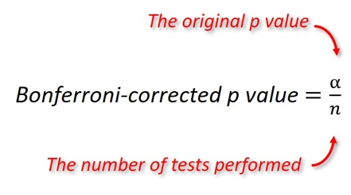

original α level / # of tests performed

Thus, if there are 10 independent tests in an investigation, the nominal significant *P* value for each test should be reduced from 0.05 to 0.005

1. **Describe the Holm method in the context of the false discovery rate (FDR) approach to adjusting p-values for multiple tests.**



More comprehensive than Bonferroni. Note: clench

Although the Bonferroni is simple to calculate, it suffers from a lack of [statistical power](https://www.statisticshowto.com/statistical-power/). The Holm-Bonferroni method is also fairly simple to calculate, but it is more powerful than the single-step Bonferroni.

The Holm method is a close relative to the Bonferroni correction with slightly different threshold levels.

Holm-Bonferroni = original α level/ (n – rank + 1)

n = number of tests

1. **Recognize and apply the Holm function to calculate adjusted p-values.**



Designed for multiple hypothesis testing, the Holm’s method iteratively accepts and rejects hypotheses.

Holm-Bonferroni (HB) = original critical alpha value (usually .05) / (n – rank + 1)

1. **Understand the process of accepting and rejecting tests using Holm method.**



Holm-Bonferroni = α / (n – rank + 1)  
Holm-Bonferroni = .05 / 4 – 1 + 1 = .05 / 4 = .0125.

Holm's step-down-procedure is applied to p-values. It controls the FWER in the strong sense under arbitrary dependency.

Step 1: Order the p-values from smallest to largest

H4 = 0.005

H1 = 0.01

H3 = 0.03

H2 = 0.04

Step 2: Work the Holm-Bonferroni formula for the first rank:  
HB = Target α / (n – rank + 1)  
HB = .05 / 4 – 1 + 1 = .05 / 4 = .0125.

Step 3: Compare the first-ranked (smallest) p-value from Step 1 to the alpha level calculated in Step 2:  
Smallest p-value, in Step 1 (H4 = 0.005) < Alpha level in Step 2 (.0125).

Reject if p-value < new alpha level.

If the p-value is smaller, reject the null hypothesis for this individual test.

The p-value of .005 is less than .0125, so the null hypothesis for H4 is rejected.

Step 4: Repeat the HB formula for the second rank .  
HB = Target α / (n – rank + 1)  
HB = .05 / 4 – 2 + 1 = .05 / 3 = .0167

Step 5: Compare the result from the HB formula in Step 4 to the second-ranked p-value:  
Second ranked p-value, in Step 1 (H1 = 0.01) < Alpha level in Step 2 (.0167).  
The p-value of .01 is less than .0167, so the null hypothesis for H1 is rejected as well.

Step 6: Repeat the HB formula for the third rank.  
HB = Target α / (n – rank + 1)  
HB = .05 / 4 – 3 + 1 = .05 / 2 = .025

Step 7: Compare the result from the HB formula in Step 6 to the third-ranked p-value:  
Third ranked p-value, in Step 1 (H3 = 0.03) > Alpha level in Step 6 (.025).  
The p-value of .03 is greater than .025, so the null hypothesis for H3 is not rejected.

The testing stops when you reach the first non-rejected hypothesis. All subsequent hypotheses are non-significant (i.e. not rejected).

1. **Describe the false discovery approach to adjusting p-values in the presence of multiple tests.**

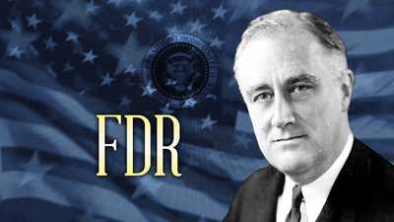  



Less Stringent.

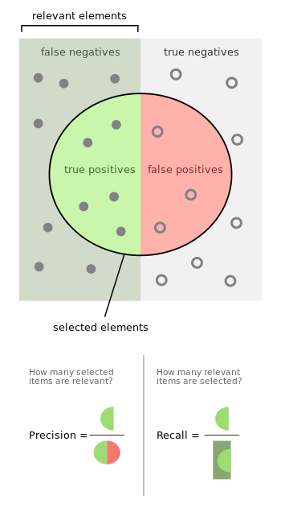

TPR = Sensitivity

TNR = Specificity

FNR = 1-Sensitivity

FPR = 1-Specificity

If you wish to control the FDR, then use Benjamini-Hochberg.

If you wish to control the FWER, then use Bonferroni (or by Holm, slightly more powerful and therefore superior).

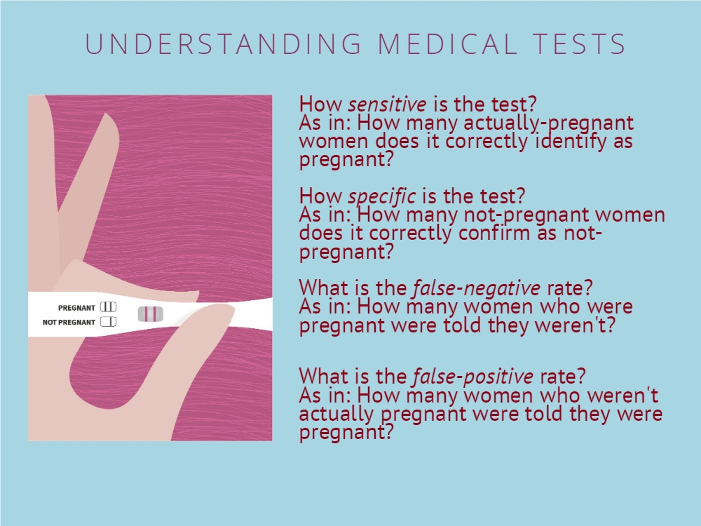

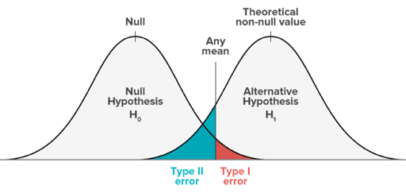Note: Both distributions fall within main distribution

1. **Recognize and apply the BHY formula to calculate adjusted p-values.**

  

 Adjusting p-values to reduce FDR.

Note: Adjusted p-value = q-value

Running the B-H procedure will decrease the number of false positives.

A false discovery = a false positive = Type I error. Incorrectly rejecting the null hypothesis. So, you want to adjust your p-values.

Adjusting the rate helps to control for the fact that sometimes small p-values (less than 5%) happen by chance, which could lead you to incorrectly reject the true null hypotheses.

In other words, the B-H Procedure helps you to avoid [Type I errors](https://www.statisticshowto.com/probability-and-statistics/statistics-definitions/type-i-error-type-ii-error-decision/)(false positives).

1. Put the individual p-values in ascending order.
2. Assign ranks to the p-values. For example, the smallest has a rank of 1, the second smallest has a rank of 2.
3. Calculate each individual p-value’s Benjamini-Hochberg critical value, using the

**=(i/m) Q, where:**

i = the individual p-value’s rank,

m = total number of tests,

Q = the false discovery rate (a percentage, chosen by you).

1. Compare your original p-values to the critical B-H from Step 3; find the largest p value that is smaller than the critical value.

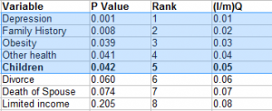

1. **Understand the process of accepting and rejecting test using BHY method.**

The Benjamini-Hochberg Procedure (BHY) is a powerful tool that decreases the [false discovery rate](https://www.statisticshowto.datasciencecentral.com/false-discovery-rate/) (FDR).

   Adjusting p-values to reduce FDR.

t

Compare your original p-values to the critical B-H from Step 3; find the largest p value that is smaller than the critical value.

< (i/m)Q



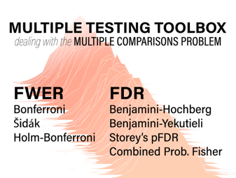

* 1. Bonferroni "punishes" all input p-values equally, whereas Benjamini-Hochberg (as a way to control the FDR) "punishes" p-values accordingly to their ranking. If you have few tests, it should not make too much of a difference, but if you have many tests (as for example when you test all 20,000 human protein coding genes or even larger sets), it will make a difference.

In this case Bonferroni will produce false negatives, in other words it will discard significant observations. Therefore, some usually use Benjamini-Hochberg.

2) The advantage of Bonferroni is that you can calculate it for one test in your head without knowing the p-values for all the other n-1 tests. That can be helpful when you want to get an instant impression of what your data yields.

1. **Explain the relationship between avoiding false discoveries (FDR) and missing on profitable opportunities.**

[According to Marcos Lopez de Prado](https://www.linkedin.com/pulse/greatest-fraud-financial-history-marcos-lopez-de-prado/), no such protections are offered to financial consumers, leaving them vulnerable to unproven investment strategies.

Precision is more important than recall for investments. A bad investment is worse than a missed opportunity. Not so for identifying poison apples. Recall will be more important.

* + 1. **Artificial Intelligence (AI) and technology trends.**
    2. **Describe the pitfalls that an organization might face if prudence is not exercised as it employs AI.**
* BIAS in the input data, process, and outcome when profiling customers and scoring credit.
* Due diligence risk in the supply chain.
  1. **Explain why boards of organizations employing AI must have sufficient understanding of AI.**

The board is responsible for the nature and extent of significant risks is willing to take in achieving its strategic objectives.

* 1. **Describe the relationship between digitization, big data, and AI**

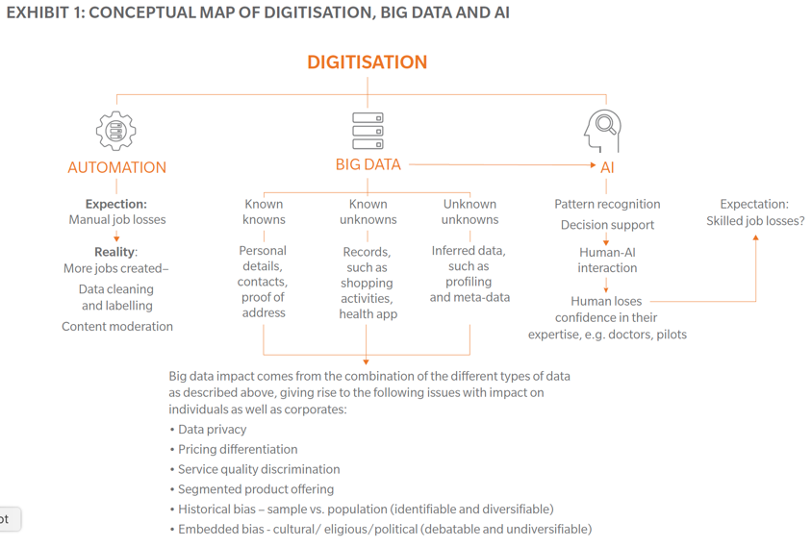

* 1. **Describe examples of “known knowns”, “know unknowns” and “unknown unknowns” in the context of big data.**

 

Known Knowns: Data which we can check and validate. Example: Bank account information or various forms.

Known Unknowns: Data that arises from people’s activities. Example: Fitness wearables. How is it anonymized?

Unknown Unknowns: Data created without our knowledge. Example: Shopping profile buckets are created that you do now know about based on online behavior.

* 1. **Describe two key aspects of cybersecurity in the context of AI.** 
     1. The function of cybersecurity in securing all aspects of digital and data transformation and resilience.
     2. The disruption of the cybersecurity industry itself. This is happening because of advances in adversarial threats that leverage AI to render accepted methods of protection ineffective. AI is becoming too advanced.

**9.8.2 Applications of Artificial intelligence (AI) in financial services.**

1. **Explain the key benefit of AI in risk management with the asset management industry.**

Since the 1990s, more statistics have been developed to address the non-linear nature of real-world events.

1. **Explain the key benefit of AI in alpha generation using big data.**

Investors are inundated with information now. Correlations can be made with all of the data.

1. **Describe the relevance of AI for long-term and short-term investors**

Short term is influenced by catalysts.

Long term AI can help better understand a company. ESG risks.

1. **Describe applications of AI in various areas of banking, such as customer service, underwriting, cross-selling of products, and fraud detection.**

Customer Service

Chatbots and virtual assistants for frequently asked questions.

Underwriting

Banks have relied on credit scores. AI makes the process more efficient.

Cross-selling

AI gives banks the ability to accurately and promptly predict the needs of the customer.

Fraud detection

The most important AI tool for banks. Ability to analyze millions of data points.

1. **Describe the risks insurance companies could face when using AI.**

* Data needs to be fair, explainable, and robust,
* If data is not accessible, then it is useless
* Data can be corrupted.
* AI will better inform underwriters but not replace them
* Leadership might misunderstand AI. Investment returns, international regulation

**9.9.1 Text mining and its applications in the insurance industry.** Zappa reading. New.



1. **Describe an example of a competitive advantage that an insurance company can gain through text mining.**

* Enriching the standard customer-based risk profile databases.
* A company developed an algorithm to analyze posts, likes and GPS locations in order to create a personality test.

1. **Describe and apply N-gram to analyze a document**

N is the number in a sequence of words. It can also be seen as a Markov chain.

N-grams are about CONTEXT.

1. **Describe and apply the chain rule to calculate the joint probability of words in a text.**

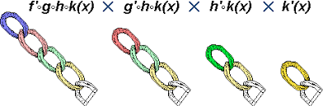

P (“the big red dog was”) =???

P(the) * P (big the) * P (red|the big) * P (dog|the big red) * P (was|the big red dog) = ???

1. **Describe and apply the chain rule of probability calculation when applying an N-gram** **language model**

The calculation of any member of the joint distribution of a set of random variables using only conditional probabilities.

The rule is useful in the study of Bayesian networks, which describe a probability distribution in terms of conditional probabilities.

1. **Describe the tokenization process when applied to a document**

First thing you do when examining a corpus. Breaking up of elements of a document into tokens.

1. **Describe the use of stop-words in reducing the number of features of a document**



If you are working with basic NLP techniques like BOW, Count Vectorizer or TF-IDF (Term Frequency and Inverse Document Frequency) then removing stopwords is a good idea because stopwords act like noise for these methods.

If you are working with LSTM’s or other models which capture the semantic meaning and the meaning of a word depends on the context of the previous text, then it becomes important NOT to remove stopwords.

1. **Describe the stemming pre-processing approach when applied to a document.**

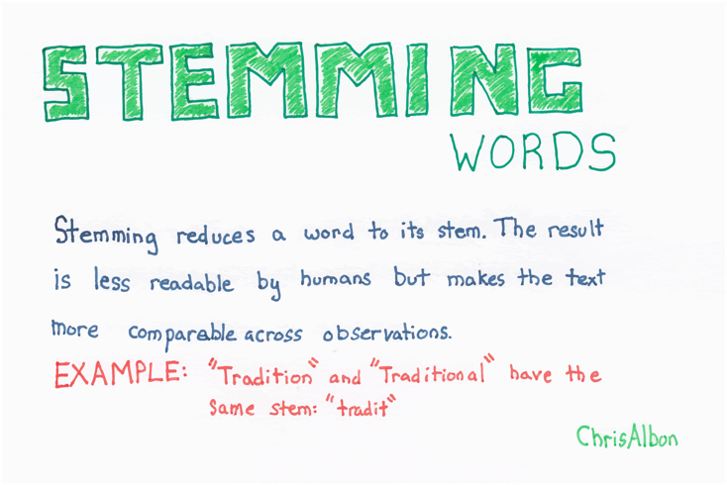

“tradition” and “traditional” 🡪 “tradit”

1. **Describe the lemmatization pre-processing approach when applied to a document.**

 Note: Lemon… it gives you back the whole word.

1. **Describe, interpret, and apply term frequency TF and inverse term frequency IDF algorithms.**

TF = number of occurrences of word / total number of words

IDF = log (total number of documents in the collection / number of documents the word appears in)

TF-IDF is just multiplied together.

1. **Explain the objective of the simplest version of a continuous bag of words (CBOW)**

**algorithm.**

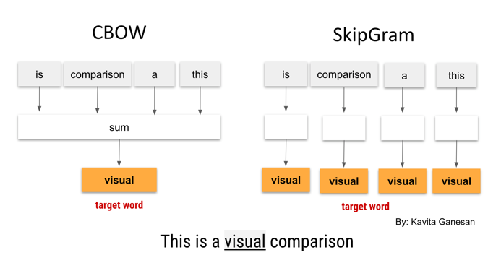

In the CBOW model, the distributed representations of context (or surrounding words) are combined to predict the word in the middle.

While in the Skip-gram model, the distributed representation of the input word is used to predict the context. Opposite.

1. **Describe the part-of-speech tagging (POS) pre-processing approach when applied to a** **document.**

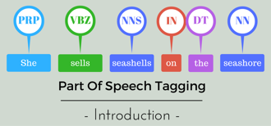

The process of marking up a word in a text (corpus) as corresponding to a particular part of speech.

